July 2026

June 29 – July 3 Students to Camp Copass

July 5 9:15 am Celebrating Our Country’s 250th Birthday,
Breakfast and Fellowship
10:00 am Worship Service
11:30 am Life Group 1, Book of James, Fellowship Hall

July 7 6:30 pm Life Group 2, Book of James, Fellowship Hall

July 12 9:15 am Breakfast and Fellowship
10:00 am Youth Camp Recap and Worship Service
11:30 am Youth Pizza Party/Camp Debrief

July 13 6:00 pm Game Night and Fellowship at the Bridge

July 14 11:30 am Women’s Luncheon, Bold Bar B Q, Wylie

July 15 6:30 pm Student Ministry Social Activity

July 16 9:00 am Bridge Breakfast @ Ballard Street Café

July 19 9:15 am Breakfast and Fellowship
10:00 am Worship Service

July 26 9:15 am Breakfast and Fellowship
10:00 am Worship Service
11:30 am Quarterly Business Meeting

August 2026

Aug 2 9:15 am Breakfast and Fellowship
10:00 am Worship Service

Aug 5 6:30 pm Student Ministry (Social Activity)

Aug 9 9:15 am Breakfast and Fellowship
10:00 am Worship Service

Aug 10 6:00 pm Game Night and Fellowship at the Bridge

Aug 11 11:30 am Woman’s Luncheon @ Country Burger, Murphy

Aug 15 9:00 am “Coffee and Conversations: Honoring Our
Veteran Heros”

Aug 16 9:15 am Breakfast and Fellowship
10:00 am Worship Service

Aug 19 6:30 pm Student Ministry (Fall Kickoff)

Aug 20 9:00 am Bridge Breakfast @ Ballard Street Café

Aug 23 9:15 am Breakfast and Fellowship
10:00 am Worship Service

Aug 29 11:30 am Volunteer Appreciation Luncheon

Aug 30 9:15 am Breakfast and Fellowship
10:00 am Worship Service and King-size Candy Bar
Celebration for Summer Reading

For the most current information on events, activities and opportunities, visit The Bridge website, jointhebridge.com/bridge-events.
"Same Page" Summer Bible Reading Challenge Continues Through August!
We want to be a community transformed by God's Word, and the best way to do that is to read it together. All summer, we will be reading through the New Testament. If you've struggled with Bible reading plans in the past, this one is for you! Here is our mindset for the summer:
- Habit over Perfection: Our goal is building a lifelong habit, not finishing a perfect checklist.
- Just Jump In: Think of it like meals—if you missed breakfast, you don't eat two meals at lunch. If you fall behind in the reading, skip what you missed and just jump back in on today's passage!
- It’s Faster Than You Think: The daily reading takes about the time it takes to scroll social media. Let's trade screen time for Scripture time this summer! Grab a reading plan this Sunday and let’s get on the same page.

Save the Date – Saturday, August 15, 9:00 am – Coffee and Donuts
“Coffee and Conversations: Honoring Our Veteran Heros” will be hosted at the church. Please share the detail with any area veterans who might enjoy joining us.

Pumpkin Patch 2026 – Pumpkins are scheduled to arrive Friday, October 2, at 4:00 pm!! Please mark your calendar and invite your family and friends for pumpkin unloading as we kick off our 2026 Pumpkin Patch. If you’d like to help with the planning, please talk with Kathy Boese or Kay Gribbin.

If you have changes or corrections to the current calendar or items to be added to future calendars, please email Kay Gribbin at kaygribbin@jointhebridge.com

The Bridge
Events, Activities and Opportunities

July/August 2026

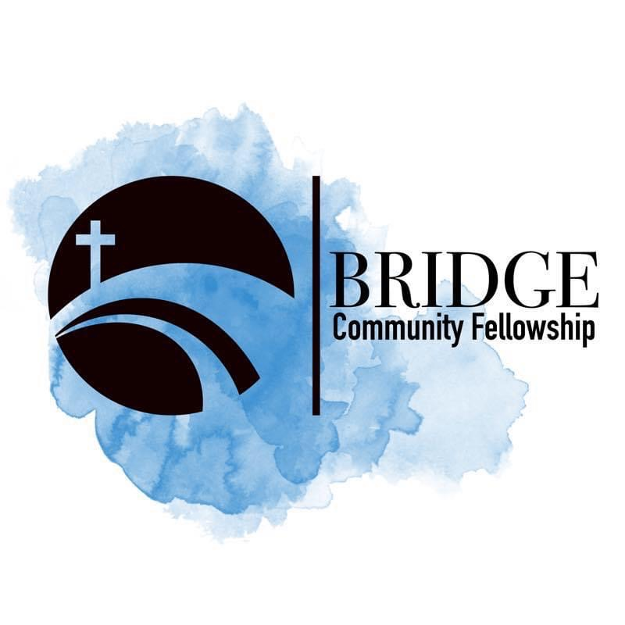
Humbly Follow Christ as a Community

Bridge Weekly Worship Service
Sundays – 10:00 am
7503 E Parker Rd
Lucas, Tx 75002

