March 2026

Mar 1 9:15 am Breakfast and Fellowship
10:00 am Worship Service

Mar 4 6:30 pm Student Ministry

Mar 8 9:15 am Breakfast and Fellowship
10:00 am Worship Service

Mar 9 6:00 pm Game Night and Fellowship at the Bridge
(Game Night is moving to the second
Monday of the month)

Mar 10 11:30 am Women’s Luncheon @ Creekside Fine Grill

Mar 11 6:30 pm Student Ministry

Mar 15 9:15 am Breakfast and Fellowship
10:00 am Worship Service

Mar 19 9:00 am Bridge Breakfast @ Ballard Street Café

Mar 19 and 20 Church-wide Garage Sale (New Date)

Mar 22 9:15 am Breakfast and Fellowship
10:00 am Worship Service

Mar 25 6:30 pm Student Ministry

Mar 28 1:30 pm Coffee and Conversations: Honoring our
Veteran Heros (Hosted by VITAS Healthcare)

Mar 29 9:15 am Breakfast and Fellowship
10:00 am Palm Sunday Worship Service
11:30 am Lunch, Games and Activities

April 2026

April 1 6:30 pm Student Ministry

April 3 6:00 pm Good Friday Service

April 5 9:15 am Breakfast and Fellowship
10:00 am Easter Sunday Worship Service

April 8 6:30 pm Student Ministry

April 12 9:15 am Breakfast and Fellowship
10:00 am Worship Service

April 13 6:00 pm Game Night and Fellowship at the Bridge

April 14 11:30 am Woman’s Luncheon @ Woodbridge Café

April 15 6:30 pm Student Ministry

April 16 9:00 am Bridge Breakfast @ Ballard Street Café

April 19 9:15 am Breakfast and Fellowship
10:00 am Worship Service

April 22 6:30 pm Student Ministry

April 26 9:15 am Breakfast and Fellowship
10:00 am Worship Service
11:30 am Business Meeting
12:00 pm Prayer Warriors

April 29 6:30 pm Student Ministry

Jesus Showed Up – Community and Missions Outreach Plan for 2026
The Outreach Team is pleased to share with you our outreach focus for 2026. Our hope is that everyone has an opportunity to support our outreach efforts in a way that best fits your circumstances and giving preferences. Please see the handout for more information.
- We’re planning activities and opportunities for each quarter of the year. Ongoing updates will be provided in the weekly announcements.
- Watch for the new date for Feed My Starving Children.
- We will continue the clothing drive in support of City Missions for a couple of additional weeks in March.
- A church-wide garage sale will be held March 20-21 with proceeds benefitting our outreach organizations.

Holy Week Services
- Sunday, March 29, Palm Sunday Service, lunch and activities
- Friday, April 3 at 6:00 pm, Good Friday Service
- Sunday, April 5, Easter/Resurrection Sunday



VITAS Healthcare will host a casual get-together for our area Vets on Saturday, March 28 from 1:30-3:00 pm at The Bridge. For more information, talk with Grace Sadowski.

Monthly Events and Activities
For the most current information on events, activities and opportunities, visit The Bridge website, jointhebridge.com/bridge-events.

If you have changes or corrections to the current calendar or items to be added to future calendars, please email Kay Gribbin at kaygribbin@jointhebridge.com

The Bridge
Events, Activities and Opportunities

March/April 2026

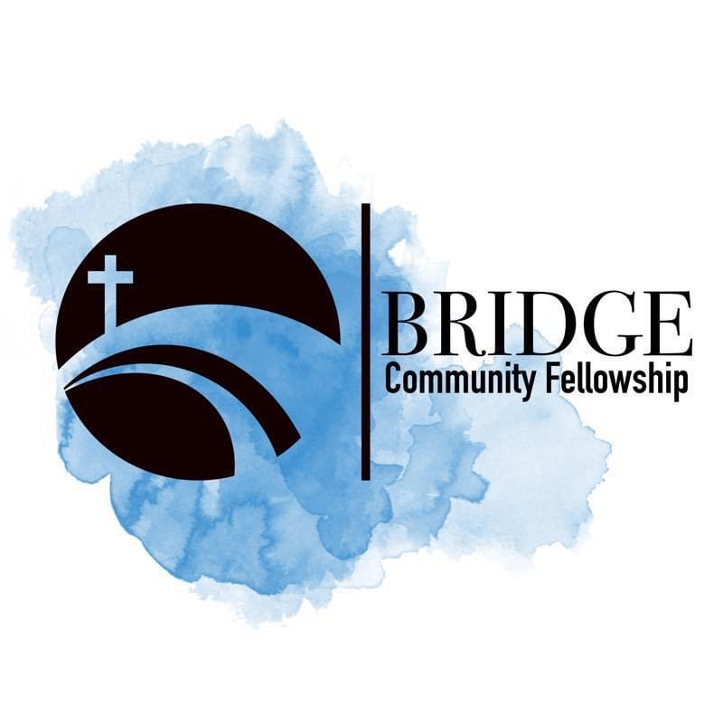
Humbly Follow Christ as a Community

Bridge Weekly Worship Service
Sundays – 10:00 am
7503 E Parker Rd
Lucas, Tx 75002

