February 2026

Feb 1 9:15 am Breakfast and Fellowship
10:00 am Worship Service
11:30 am Q4 2025 Business Meeting
12:00 pm Prayer Warriors

Feb 3 6:00 pm Game Night and Fellowship at the Bridge

Feb 4 6:30 pm Student Ministry

Feb 7 9:00 am Craft Day and Décor Change @ The Bridge

Feb 8 9:15 am Breakfast and Fellowship
10:00 am Worship Service

Feb 10 11:30 am Woman’s Luncheon @ Bold BBQ, Downtown
Wylie

Feb 11 6:30 pm Student Ministry

Feb 15 9:15 am Breakfast and Fellowship
10:00 am Worship Service

Feb 18 6:30 pm Student Ministry

Feb 19 9:00 am Bridge Breakfast @ Ballard Street Café

Feb 22 9:15 am Breakfast and Fellowship
10:00 am Worship Service

Feb 25 6:30 pm Student Ministry

Feb 28 9:00 am Spring Décor Change

March 2026

Mar 1 9:15 am Breakfast and Fellowship
10:00 am Worship Service

Mar 4 6:30 pm Student Ministry

Mar 8 9:15 am Breakfast and Fellowship
10:00 am Worship Service

Mar 9 6:00 pm Game Night and Fellowship at the Bridge
(Game Night is moving to the second
Monday of the month)

Mar 10 11:30 am Women’s Luncheon @ Creekside Fine Grill

Mar 11 6:30 pm Student Ministry

Mar 13 and 14 Church-wide Garage Sale

Mar 15 9:15 am Breakfast and Fellowship
10:00 am Worship Service

Mar 19 9:00 am Bridge Breakfast @ Ballard Street Café

Mar 22 9:15 am Breakfast and Fellowship
10:00 am Worship Service
11:30 am First Quarter Business Meeting
12:00 pm Prayer Warriors

Mar 25 6:30 pm Student Ministry

Mar 29 9:15 am Palm Sunday Breakfast and Fellowship
10:00 am Worship Service
11:30 am Palm Sunday Lunch, Games and Activities



Jesus Showed Up – Community and Missions Outreach Plan for 2026
The Outreach Team is pleased to share with you our outreach focus for 2026. Our hope is that everyone has an opportunity to support our outreach efforts in a way that best fits your circumstances and giving preferences. Please see the handout for more information.
- We’re planning activities and opportunities for each quarter of the year. Ongoing updates will be provided in the weekly announcements.
- Watch for the new date for Feed My Starving Children.
- The clothing drive in support of City Missions will run through the month of February.
- A church-wide garage sale will be held March 13-14 with proceeds benefitting our outreach organizations.

Save the Date:
- Sunday, March 29, Palm Sunday lunch, activities and games
- Friday, April 3, Good Friday Service
- Sunday, April 5, Easter/Resurrection Sunday

Volunteer Recognition Luncheon – Rescheduled for May 9, 2026.

Monthly Events and Activities
For the most current information on events, activities and opportunities, visit The Bridge website, jointhebridge.com/bridge-events.

If you have changes or corrections to the current calendar or items to be added to future calendars, please email Kay Gribbin at kaygribbin@jointhebridge.com

The Bridge
Events, Activities and Opportunities

February/March 2026
(Revised)

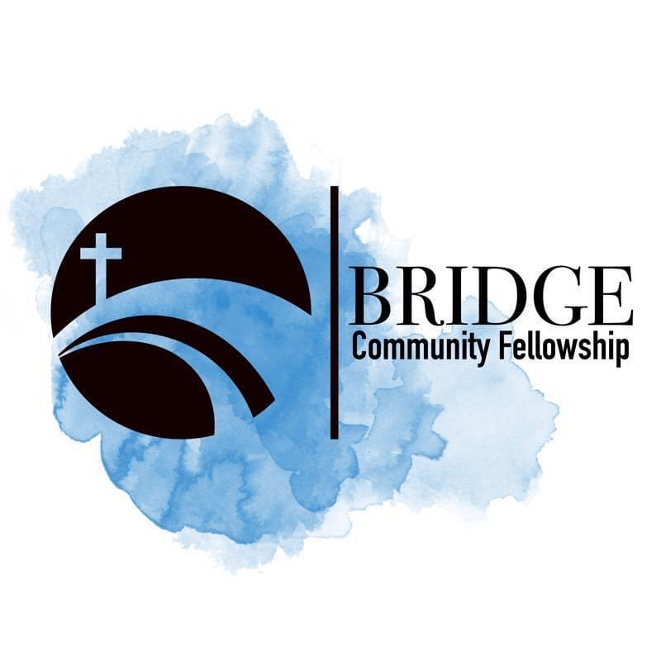
Humbly Follow Christ as a Community

Bridge Weekly Worship Service
Sundays – 10:00 am
7503 E Parker Rd
Lucas, Tx 75002

