January 2026

Jan 4 9:15 am Breakfast and Fellowship
10:00 am Worship Service

Jan 6 6:00 pm Game Night and Fellowship at the Bridge

Jan 7 6:30 pm Student Ministry

Jan 11 9:15 am Breakfast and Fellowship
10:00 am Worship Service

Jan 13 11:30 am Women’s Luncheon @ Eddie’s Diner, Parker
Rd

Jan 14 6:30 pm Student Ministry

Jan 15 9:00 am Bridge Breakfast @ Ballard Street Café

Jan 18 9:15 am Breakfast and Fellowship
10:00 am Worship Service

Jan 21 6:30 pm Student Ministry

Jan 25 9:15 am Breakfast and Fellowship
10:00 am Worship Service
11:45 am Quarterly Business Meeting
12:15 pm Prayer Warriors

Jan 28 7:15 pm Feed My Starving Children

February 2026

Feb 1 9:15 am Breakfast and Fellowship
10:00 am Worship Service

Feb 3 6:00 pm Game Night and Fellowship at the Bridge

Feb 4 6:30 pm Student Ministry

Feb 7 9:00 am Craft Day and Décor Change @ The Bridge

Feb 8 9:15 am Breakfast and Fellowship
10:00 am Worship Service

Feb 10 11:30 am Woman’s Luncheon @ Bold BBQ, Downtown
Wylie

Feb 11 6:30 pm Student Ministry

Feb 15 9:15 am Breakfast and Fellowship
10:00 am Worship Service

Feb 18 6:30 pm Student Ministry

Feb 19 9:00 am Bridge Breakfast @ Ballard Street Café

Feb 21 11:30 am Volunteer Recognition Luncheon @
The Bridge

Feb 22 9:15 am Breakfast and Fellowship
10:00 am Worship Service

Feb 25 6:30 pm Student Ministry



Jesus Showed Up – Community and Missions Outreach Plan for 2026
The Outreach Team is pleased to share with you our outreach focus for 2026. Our hope is that everyone has an opportunity to support our outreach efforts in a way that best fits your circumstances and giving preferences. Please see the handout for more information.
- We’re planning activities and opportunities for each quarter of the year. Ongoing updates will be provided in the weekly announcements.
- Sign up to join us for Feed My Starving Children on Wednesday, January 28 at 7:15 pm.
- We’re planning a clothing drive in support of City Missions and church-wide garage sale for March 13-14 with proceeds benefitting our outreach organizations. More information will be provided soon.

Quarterly Business Meeting
Plan to attend our Quarterly Business Meeting, January 25, immediately following Sunday Service.

Monthly Events and Activities
For the most current information on events, activities and opportunities, visit The Bridge website, jointhebridge.com/bridge-events.

If you have changes or corrections to the current calendar or items to be added to future calendars, please email Kay Gribbin at kaygribbin@jointhebridge.com

The Bridge
Events, Activities and Opportunities

January/February 2026

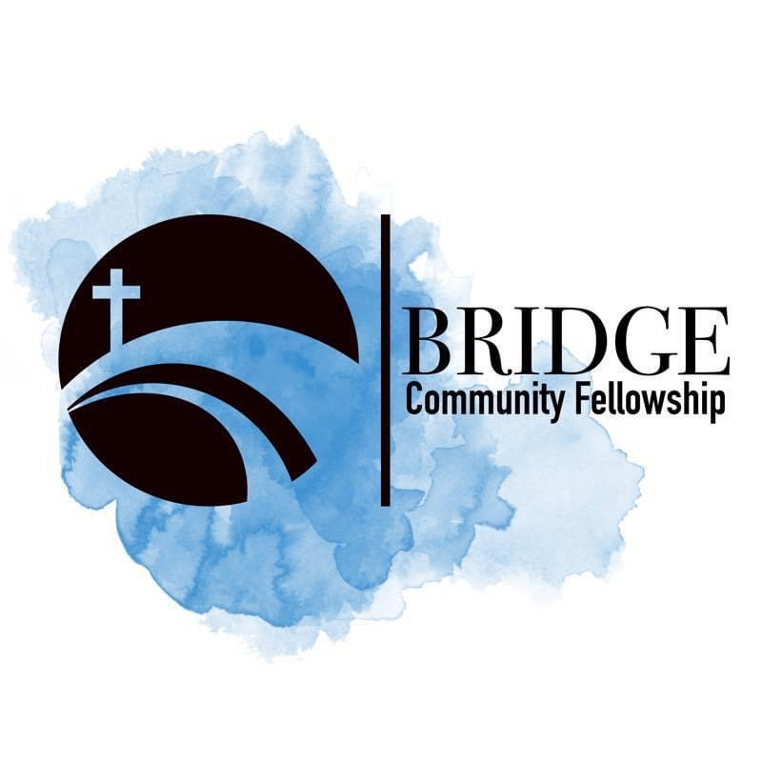
Humbly Follow Christ as a Community

Bridge Weekly Worship Service
Sundays – 10:00 am
7503 E Parker Rd
Lucas, Tx 75002

