**August**

Aug 3 8:30 am Discipleship Class w/Pastor Kyle

9:15 am Breakfast and Fellowship

10:01 am Worship Service

11:30 am Bridge Kids Training

Aug 5 6:00 pm Game Night and Fellowship at the Bridge

Aug 10 8:30 am Discipleship Class w/Pastor Kyle

9:15 am Breakfast and Fellowship

10:01 am Worship Service

11:30 am Bridge Kids Training

Aug 13 6:30 pm Student Ministry

Aug 16 9:00 am Woman’s Group Craft Day and Fellowship

Aug 17 8:30 am Discipleship Class w/Pastor Kyle

9:15 am Breakfast and Fellowship

10:01 am Worship Service

10:20 am Bridge Kids Kick Off

Aug 19 11:30 am Woman’s Luncheon @ Frankie’s Casa on Ballard

Aug 20 6:30 pm Student Ministry

Aug 21 9:00 am Bridge Breakfast @ Ballard Street Café

Aug 24 8:30 am Discipleship Class w/Pastor Kyle

9:15 am Breakfast and Fellowship

10:01 am Worship Service

10:20 am Bridge Kids

Aug 27 6:30 pm Student Ministry

Aug 31 8:30 am Discipleship Class w/Pastor Kyle

9:15 am Breakfast and Fellowship

10:01 am Worship Service

10:20 am Bridge Kids

11:30 am Prayor Warriors

**September**

Sept 2 6:00 pm Game Night and Fellowship at the Bridge

Sept 3 6:30 pm Student Ministry

Sept 7 8:30 am Discipleship Class w/Pastor Kyle

9:15 am Breakfast and Fellowship

10:01 am Worship Service

10:20 am Bridge Kids

Sept 10 6:30pm Student Ministry

Sept 14 8:30 am Discipleship Class w/Pastor Kyle

9:15 am Breakfast and Fellowship

10:01 am Worship Service

10:20 am Bridge Kids

Sept 16 11:30 am Women’s Luncheon @ Country Burger

Sept 17 7:15 pm Volunteer Opportunity – Feed My Starving

Children

Sept 18 9:00 am Bridge Breakfast @ Ballard Street Café

Sept 21 8:30 am Discipleship Class w/Pastor Kyle

9:15 am Breakfast and Fellowship

10:01 am Worship Service

10:20 am Bridge Kids

Sept 24 6:30 pm Student Ministry

Sept 28 9:15 am Breakfast and Fellowship

10:01 am Worship Service

10:20 am Bridge Kids

11:30 am Prayer Warriors

**Prayer Warriors Transitioning to Monthly Meetings**

The Prayer Warriors are transitioning from weekly meetings to meeting monthly on the last Sunday of the month, beginning July 27, immediately following the Sunday Services. All are invited to bring lunch and join in the prayer time. More information is available in the weekly Bridge Bulletin.

**Discipleship Class with Pastor Kyle**

Beginning Sunday, August 3, Pastor Kyle will be teaching an 8-week Discipleship Class from 8:30-9:15 am. This is an opportunity to grow deeper in your faith, understand your Bible, connect with others, and be equipped to follow Jesus in everyday life. The class will meet in the second building and is open to all.

**Re-launching Bridge Kids**

We are excited to announce that we will be re-launching Bridge Kids on Sunday, August 17, and we’re thrilled to create a fun, engaging space for our kids to grow in their faith each Sunday morning. More information is available in the weekly Bridge Bulletin.

**Monthly Events and Activities**

For the most current information on events, activities and opportunities, visit The Bridge website, [jointhebridge.com/bridge-events](https://www.jointhebridge.com/bridge-events).



**The Pumpkins are Scheduled to Arrive Saturday, October 4!**

The Pumpkin Patch Planning Committee has selected the theme for this years’ Pumpkin Patch and are finalizing plans. Stay tuned for more information and details on how you can help. Planning Committee: Kay Gribbin, Kathy Boese and Debbie Hazelwood.

If you have changes or corrections to the current calendar or items to be added to future calendars, please email Kay Gribbin at [kaygribbin@jointhebridge.com](mailto:kaygribbin@jointhebridge.com)

**The Bridge**

**Events, Activities and Opportunities**

**August/September 2025**

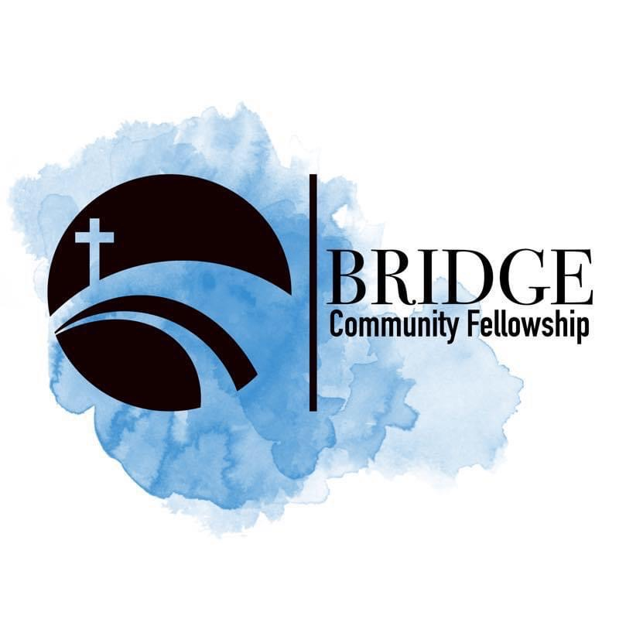

**Humbly Follow Christ as a Community**

**Bridge Weekly Worship Service**

Sundays – 10:01 am

7503 E Parker Rd

Lucas, Tx 75002