December 2025

Dec 2 6:00 pm Game Night and Fellowship at the Bridge

Dec 3 6:30 pm Student Ministry

Dec 7 9:15 am Breakfast and Fellowship
10:00 am Worship Service and Advent

Dec 9 11:30 am Woman’s Luncheon @ Frankie’s Mexican
Restaurant, Downtown Wylie

Dec 10 6:30 pm Student Ministry

Dec 14 9:15 am Breakfast and Fellowship
10:00 am Worship Service and Advent

Dec 17 6:30 pm Student Ministry

Dec 18 9:00 am Bridge Breakfast @ Ballard Street Café

Dec 21 9:15 am Breakfast and Fellowship
10:00 am Worship Service and Advent

Dec 24 4:00 pm Christmas Eve Candlelight Service

Dec 28 9:15 am Breakfast and Fellowship
10:01 am Worship Service
11:30 am Prayor Warriors

Dec 29 TBD Students and College Kids Event
Main Event Plano

January 2026

Jan 4 9:15 am Breakfast and Fellowship
10:00 am Worship Service

Jan 6 6:00 pm Game Night and Fellowship at the Bridge

Jan 7 6:30 pm Student Ministry

Jan 11 9:15 am Breakfast and Fellowship
10:00 am Worship Service

Jan 13 11:30 am Women’s Luncheon @ Eddie’s Diner, Parker
Rd

Jan 14 6:30 pm Student Ministry

Jan 15 9:00 am Bridge Breakfast @ Ballard Street Café

Jan 18 9:15 am Breakfast and Fellowship
10:00 am Worship Service

Jan 21 6:30 pm Student Ministry

Jan 25 9:15 am Breakfast and Fellowship
10:00 am Worship Service
11:45 am Quarterly Business Meeting
12:15 pm Prayer Warriors

Jan 28 7:15 pm Feed My Starving Children



Candlelight Christmas Eve Service
Please save the date and plan to join us for our Candlelight Christmas Eve Service Wednesday, December 24th at 4:00 pm. We hope you will invite your extended family and friends to join us and we’re looking into ways to share an invitation with the community.

Christmas Giving and a Renewed Focus on our Mission Outreach into the New Year
Conversations are taking place and plans are being formulated on our Christmas Giving opportunities and a renewed focus on our Mission Outreach for the coming year. We look forward to sharing detail very soon on how each of us can contribute and collectively make a positive impact.

Bridge Students and College Kids Home for the Holiday Event
The students and college kids who are home for the holiday are invited to join Gregg for a fun evening of bowling, billiards, laser tag and shuffleboard at Main Event, 3941 North Central Expressway, Plano, Tx 75023 on Monday, December 29; time to be determined. Please RSVP to Gregg by Monday, December 22.

Monthly Events and Activities
For the most current information on events, activities and opportunities, visit The Bridge website, jointhebridge.com/bridge-events.

If you have changes or corrections to the current calendar or items to be added to future calendars, please email Kay Gribbin at kaygribbin@jointhebridge.com

The Bridge
Events, Activities and Opportunities

December 2025/January 2026

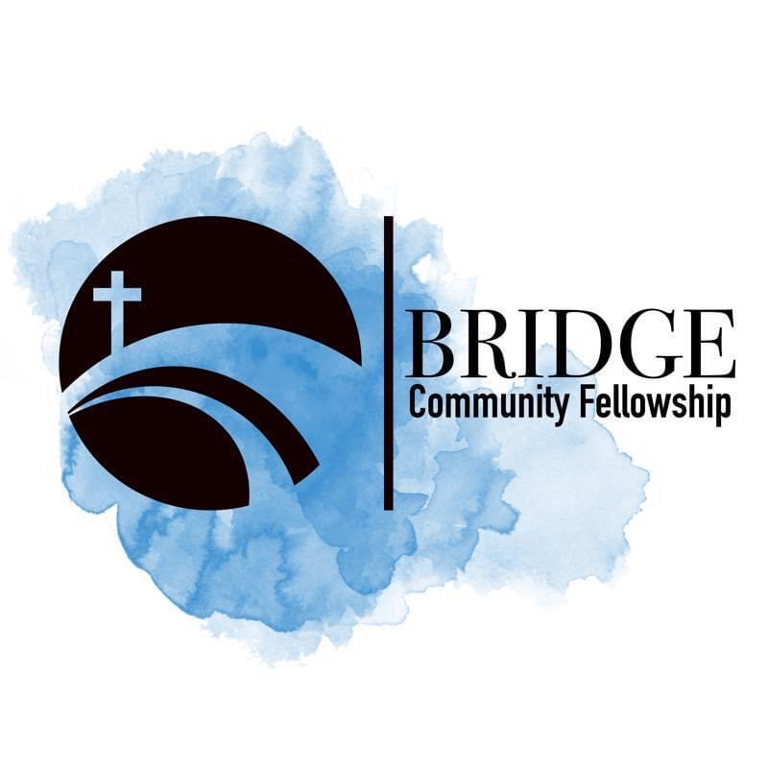
Humbly Follow Christ as a Community

Bridge Weekly Worship Service
Sundays – 10:00 am
7503 E Parker Rd
Lucas, Tx 75002

