October

Oct 1 6:30 pm Student Ministry

Oct 4 11:00 am Pumpkins Arrive!

Oct 5 9:15 am Breakfast and Fellowship
10:00 am Worship Service
10:20 am Bridge Kids
11:30 am Blessing of the Pumpkin Patch

Oct 7 6:00 pm Game Night and Fellowship at the Bridge

Oct 8 6:30 pm Student Ministry

Oct 10 11:30 am Woman’s Luncheon @ Creekside Fine Grill
(Note: New Date)

Oct 11 Noon-4:00 Fall Festival in the Pumpkin Patch

Oct 12 9:15 am Breakfast and Fellowship
10:00 am Worship Service
10:20 am Bridge Kids

Oct 15 6:30 pm Student Ministry

Oct 16 9:00 am Bridge Breakfast @ Ballard Street Café

Oct 19 9:15 am Breakfast and Fellowship
10:00 am Worship Service
10:20 am Bridge Kids

Oct 22 6:30 pm Student Ministry

Oct 26 9:15 am Breakfast and Fellowship
10:01 am Worship Service
10:20 am Bridge Kids
11:30 am Prayor Warriors
11:45 am Quarterly Business Meeting

Oct 29 6:30 pm Student Ministry

November

Nov 2 9:15 am Breakfast and Fellowship
10:00 am Worship Service
10:20 am Bridge Kids

Nov 4 6:00 pm Game Night and Fellowship at the Bridge

Nov 5 6:30 pm Student Ministry

Nov 9 9:15 am Breakfast and Fellowship
10:00 am Worship Service
10:20 am Bridge Kids

Nov 12 6:30 pm Student Ministry

Nov 14 11:30 am Women’s Luncheon @ TBD

Nov 16 9:15 am Breakfast and Fellowship
10:00 am Worship Service
10:20 am Bridge Kids

Nov 19 6:30 pm Student Ministry

Nov 20 9:00 am Bridge Breakfast @ Ballard Street Café

Nov 23 9:15 am Breakfast and Fellowship
10:00 am Worship Service
10:20 am Bridge Kids

Nov 29 9:00 am Decorating the Church for Christmas

Nov 30 9:15 am Breakfast and Fellowship
10:00 am Worship Service
10:20 am Bridge Kids
11:30 am Prayer Warriors

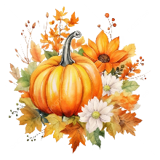
The Pumpkins are Scheduled to Arrive Saturday, October 4 at approximately 11:00 am. Everyone’s help is needed and greatly appreciated! Lunch will be provided.

Sign up to work the Pumpkin Patch:
The Bridge Community Fellowship: Cactus & Cornstalks Patch

The Pumpkin Patch will run from Sunday, October 5, through Saturday, October 25.
Hours:
• Monday–Friday: 5:00 PM – 7:00 PM
• Saturday: 12:00 PM – 8:00 PM
• Sunday: 12:00 PM – 6:00 PM
Our Fall Festival will be held from noon-4:00 on Saturday, October 11. Enjoy delicious bites from Lovin U Bar B Q food truck, cool treats from Kona Ice, music, yard games and seasonal activities. Please plan to join us for a fun afternoon!

Monthly Events and Activities
For the most current information on events, activities and opportunities, visit The Bridge website, jointhebridge.com/bridge-events.

If you have changes or corrections to the current calendar or items to be added to future calendars, please email Kay Gribbin at kaygribbin@jointhebridge.com

The Bridge
Events, Activities and Opportunities

October/November 2025

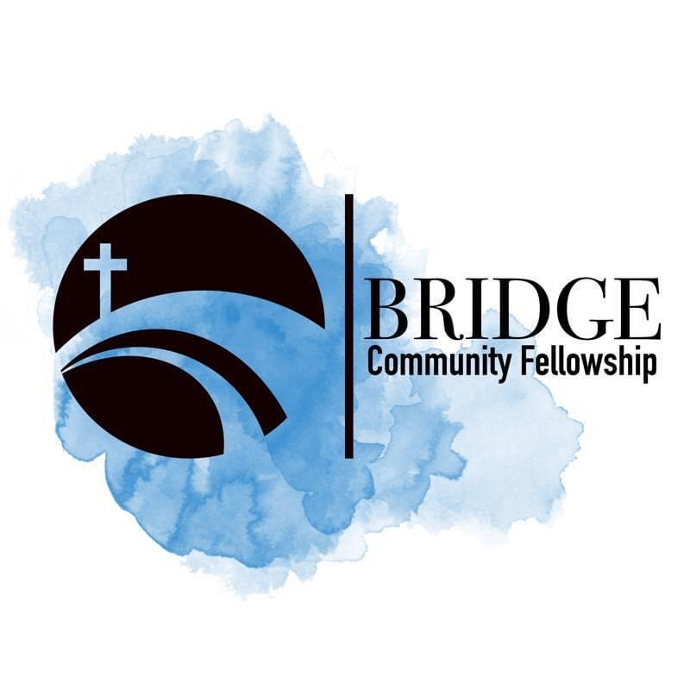
Humbly Follow Christ as a Community

Bridge Weekly Worship Service
Sundays – 10:00 am
7503 E Parker Rd
Lucas, Tx 75002

