June

June 1 @ 10:01 am Worship Service
Guest Pastor: Kyle Van Tine

June 3 @ 6:00 pm Game Night and Fellowship at the Bridge

June 4 @ 6:30 pm Student Ministry
@ 6:30 pm Praying Patriots

June 8 @ 10:01 am Worship Service
Gues Pastor: Kyle Van Tine

June 11 @ 6:30 pm Praying Patriots

June 15 @ 10:01 am Worship Service (Father’s Day)
Guest Pastor: BW Briscoe

June 17 @ 11:30 am Woman’s Luncheon @ Creekside Fine Grill

June 18 @ 6:30 pm Student Ministry
@ 6:30 pm Praying Patriots

June 19 @ 9:30 am Bridge Breakfast @ Ballard Street Café

June 22 @ 10:01 am Worship Service

June 24 @ 11:30 am Game Day and Fellowship at the Bridge

June 25 @ 6:30 pm Praying Patriots

June 28 @ 9:00 am Craft Day and Decorating the Church for Summer

June 29 @ 10:01 am Worship Service (Celebrating 4th of July)
Guest Pastor: Robert Little

June 30 – July 4 Students to Camp Copass

July

July 1 @ 6:00 pm Game Night and Fellowship at the Bridge

July 2 @ 6:30 pm Praying Patriots

July 6 @ 10:01 am Worship Service

July 9 @ 6:30 pm Praying Patriots

July 13 @ 10:01 am Worship Service

July 15 @ 11:30 am Women’s Luncheon @

July 16 @ 6:30 pm Student Ministry
@ 6:30 pm Praying Patriots

July 17 @ 9:00 am Bridge Breakfast @

July 20 @ 10:01 am Worship Service

July 22 @ 11:30 am Game Day and Fellowship at the Bridge

July 23 @ 6:30 pm Praying Patriots

July 27 @ 10:01 am Worship Service
Guest Pastor: James Cruz
@ 11:30 am Quarterly Business Meeting

July 30 @ 6:30 pm Student Ministry
@ 6:30 pm Praying Patriots

Note: The schedule for Student Ministry meetings will change to bi-weekly for the summer. Meeting dates are June 4 and 18 and July 16 and 30. The regular weekly meeting schedule will resume August 12.
Camp Copass
Students will be attending Camp July 30 – July 4.
If you’d like to contribute snacks and drinks for them to enjoy during the week, please bring them to the Church by Sunday, June 29.


It won’t be long before the pumpkins arrive!

The Pumpkin Patch Planning Committee will begin meeting in June to select our theme, plan the decorations and schedule activities for the event. If you’re interested in helping with the planning or have suggestions for the event you’d like to offer, contact Kay Gribbin.

If you have changes or corrections to the current calendar or items to be added to future calendars, please email Kay Gribbin at kaygribbin@hotmail.com

The Bridge
Events, Activities and Opportunities

June/July 2025

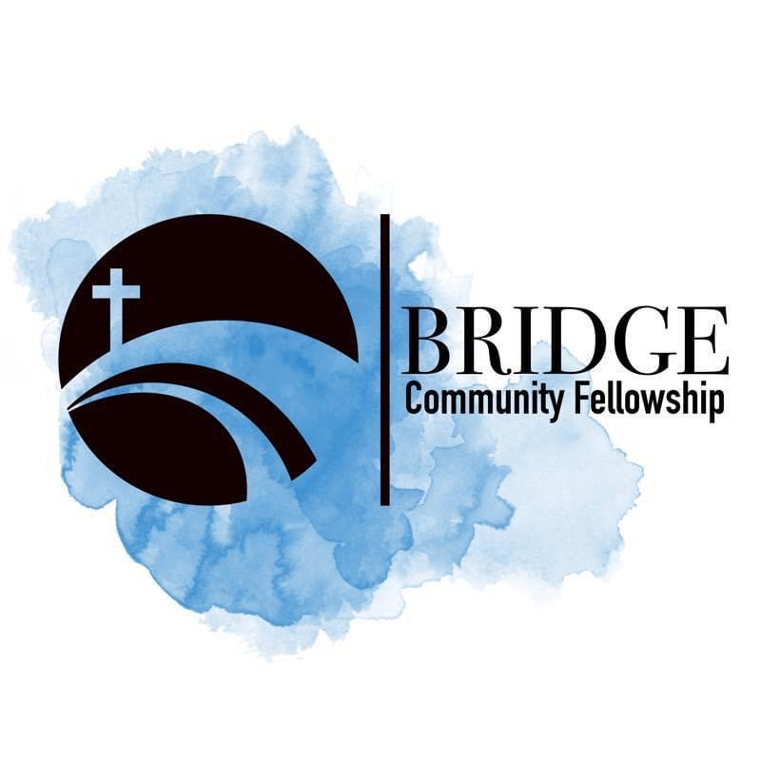
Humbly Follow Christ as a Community

Bridge Weekly Worship Service
Sundays – 10:01 am
7503 E Parker Rd
Lucas, Tx 75002

